Assignment 1 :

1.Create a table listing 3 types of printers, 2 types of scanners, and 2 types of webcams, and for each, write one real-life use case (for example: 'Inkjet printer - printing college assignments').

Device Type | Example Type | Real-Life Use Case
Printer | Inkjet Printer | Printing college assignments and color photos
Printer | Laser Printer | Printing office documents and reports
Printer | Thermal Printer | Printing shop bills and receipts
Scanner | Flatbed Scanner | Scanning certificates and documents
Scanner | Sheet-fed Scanner | Scanning multiple office papers quickly
Webcam | Built-in Webcam | Attending online classes or meetings
Webcam | External USB Webcam | Video calls and online interviews

2.Draw a labeled diagram showing how a typical home printer connects to a laptop or PC, including the connection interface used (USB, Wi-Fi, or Bluetooth).

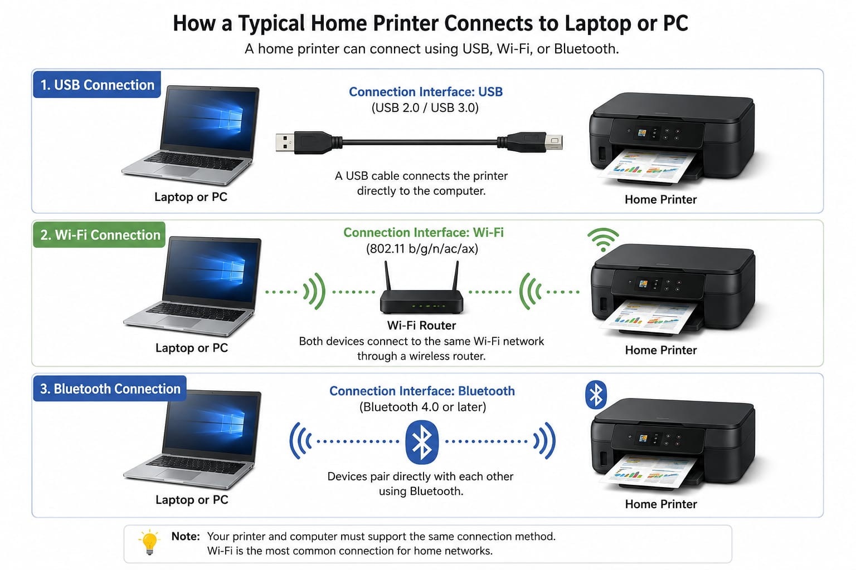

3.List three different connection interfaces (such as USB, Wi-Fi, Bluetooth) used by peripherals like printers, scanners, and webcams, and for each, name one advantage and one disadvantage.<br><br><em><strong>Hint:</strong> Think about speed, convenience, and compatibility.</em>

Connection Interface | Advantage | Disadvantage
USB | Fast and reliable wired connection | Requires a cable and an available USB port
Wi-Fi | Wireless and siutable;  multiple devices can connect | Requires Wi-Fi network and can be affected by network problems
Bluetooth | Wireless and easy to  connect for short distances | Shorter range and generally slower than USB

4.Pick any one device you use at home or college (printer, scanner, or webcam). Write step-by-step instructions for how you would connect it to your computer, including what cable or wireless method you would use and any setup steps required.

----Connecting a Printer to a Computer Using USB
- Turn on the printer and make sure it has paper and ink/toner.

- Take a USB printer cable (usually USB-A to USB-B).

- Connect one end of the USB cable to the printer.

- Connect the other end to an available USB port on the computer.

- Wait for Windows to detect the printer.

6. If Windows does not install it automatically, install the printer driver from the
Printer manufacturer's website or installation software.

7.Open Settings → Bluetooth & devices → Printers & scanners.

8.Check that your printer appears in the list.

9.Select the printer and choose Print a test page to confirm that the connection

